Appendix: Using the PASCO motion sensor
There are two types of motion sensors. One type is black and has two plugs (yellow and black). The other is blue and has a single PasPort plug. An illustration of the black sensor is shown below.
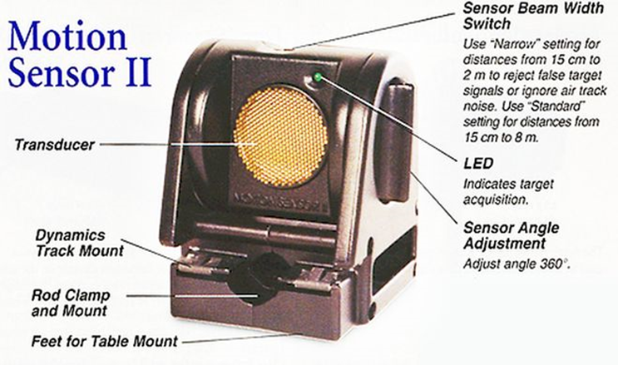

To set up the motion sensor
- Connect the motion sensor to the “PASCO 850 Universal Interface”. For the black sensor, insert the yellow plug to left of black plug on the interface. For the blue sensor, connect the sensor to one of the PasPort ports on the interface.
- Start PASCO Capstone on the lab computer (shortcut provided on the lab computer desktop).
- Click on the “Hardware Setup” (see far left side of screen, under “Tools”). You should see a picture of the “PASCO 850 Universal Interface” the computer screen (if not, see instructor). If the blue motion sensor is being used, it should automatically recognize it. If the black motion sensor is being used, you need to click on the digital channel location that the yellow plug is plugged into. Then, from the list of possible sensors, choose the Motion Sensor II. Once the hardware has been set up, you can remove the “Hardware Setup” screen by clicking on the “Hardware Setup” button again.
- The motion sensor “sees” objects through its transducer (see illustration above). Rotate the motion sensor (via the sensor angle adjustment; see illustration) so that the transducer is facing the object that you want it to sense.
- Set the “motion sensor beam width switch” (on top of sensor; see illustration) to the “cart” setting for a narrow beam or the “person” setting for a wide beam, as appropriate for your situation. A wide beam is more likely to receive interference from nearby objects, but may be necessary if the target and sensor are not perfectly aligned. When used with a track, it is easier to align the motion sensor with the target (a cart on the track), so a narrow beam can be used with a track.
Note: It is recommended that you select a 50-Hz sample rate (see bottom of the screen, where the “Record” button is), as this provides a “cleaner” plot to read (since there will be more data “points” on the graph).
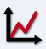
To see a position, velocity and/or acceleration vs. time graphs
- To see a graph, drag the “Graph” option (far right, under “Display”) to the main screen area. You can then choose which measurement you want to plot.
- Press Record to start sampling and Stop to stop sampling.
Note: Once you press “Record,” the sensor will start “clicking.” This is just to let you know that it is on and working. On the computer screen, the Capstone software should be plotting points on a graph. To check if the motion sensor is working properly, move your hand back and forth in front of the sensor. If “position” is being plotted, the graph will indicate how far your hand is from the motion sensor. If “velocity” is being plotted, the graph will indicate how fast your hand is moving away or toward the sensor.
To remove or layer runs

- You can delete a run via the control panel under the graph.
- To see prior runs, click on the multicolored triangle just above the graph (see picture to right). You can then select which runs you want to see. The triangle itself acts a toggle between whether you want to see one at a time or multiple runs at a time.
Note: Use ctrl-z to undo the last action.
Magnifying or shrinking the graph
One can expand or contract each axis by placing the cursor over the numbers on the axis you’d like to expand or contract and then dragging the cursor toward (to contract) or away from (to expand) the origin.
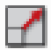
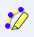
Another way is to highlight a section of the graph and then expand that section. To do this, use the highlight icon above the graph (it is the fourth one). This will create a lightly shaded rectangle that you can move and resize to cover any portion of the graph. Click the expand-to-fit icon above the graph (it is the first one) to expand that portion of the graph.
Using the “fit” function
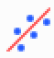
You can use the Capstone software to “fit” a line or curve to the data. To do so, choose the run that has the data and graph you wish to “fit” (by clicking on it). Then, highlight the portion of the graph that contains the described motion using the technique described above. Click on the curve-fit icon above the graph (it is the seventh one) and choose the fit you want.
Notes:
- The program will use whatever data you highlight to determine the fit – the more data you highlight, the better the fit. The highlighted portion must be large enough to give the program enough data points to find a good fit yet not so large that it samples portions that are noisy. Make sure the “fitted” curve indeed matches the observed data.
- The program rounds the fit parameters to three significant figures. If you need a higher resolution, right-click the box containing the parameters and choose “curve fit properties” then “numerical format” then “coefficients”. You can then increase the “number of significant digits”.

