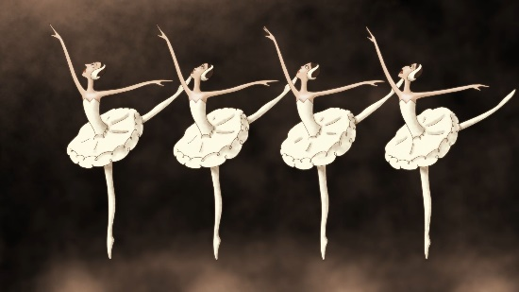
Box Ballet – Animation - 15 min. by Anton Dyakov, Saint-Petersburg, Russia
Timestamp - 1:36 [cooing]
1:40 [ambient music]
1:44 [footsteps and traffic]
1:55 [voices overlapping]
2:58 [single piano notes and ballet score]
3:30 [music stops]
3:31 [woman clears throat]
3:34 [music continues]
3:37 [ballet instructor claps for attention]
3:41 [ballet instructor slaps fingers]
3:48 [dramatic music and Russian speaking]
4:10 [upbeat music]
4:57 [tea kettle whistles, soothing music]
5:35 [crowd cheering]
5:56 [dog barks]
6:18 [punk music]
7:31 [doorbell]
7:46 [orchestra tuning]
8:01 [party music]
8:33 [ballet music]
9:30 [boxer gasps]
9:45 [clapping]
9:50 [THUMP]
9:51 [bell rings]
9:58 [bell rings]
10:17 [ballet instructor taps seat while seductive music plays, “I’m in the Mood for Love”]
11:22 [doorbell]
11:30 [doorbell]
11:38 [phone rings]
12:01 [somber music]
12:10 [BAM]
12:30 [non-specific tones]
13:03 [dramatic suspenseful music]
13:40 [defeated soothing music]
14:30 [wind and birds singing]
15:00 [kettle whistles]
15:04 [ballet music]
15:29 [punk music]

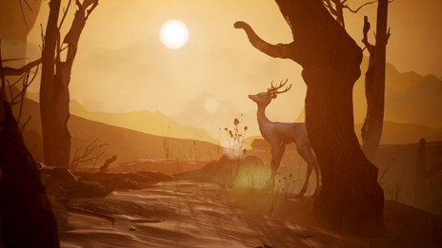

Metamorphosis - 4 min. by Wang Xi, LA, CA, US

Timestamp - 16:50 [soft instrumental]
18:15 [crow caws]

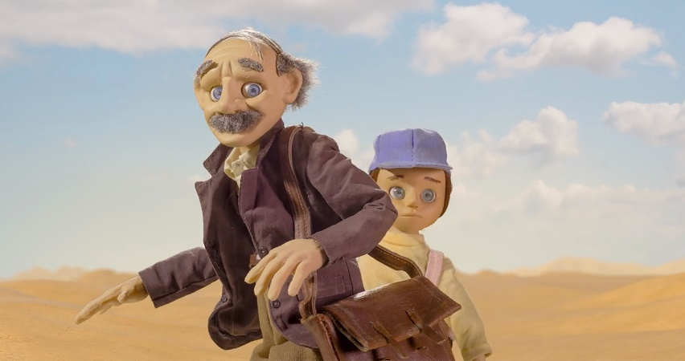’
Green Grass - 8 min. by Michael Greco, Toronto, Ontario, Canada
Timestamp – 20:29 [Automobile engine]
20:40 [automobile doors open]
20:50 [automobile door closes]
20:55 [Automobile drives away]
21:10 [Ominous Music]
21:23 [insects chirping]
22:00 [Wind Blows]
22:10 [roaring wind]
22:24 [Wind stops]
22:30 [soft piano]
26:01 [drum thump]

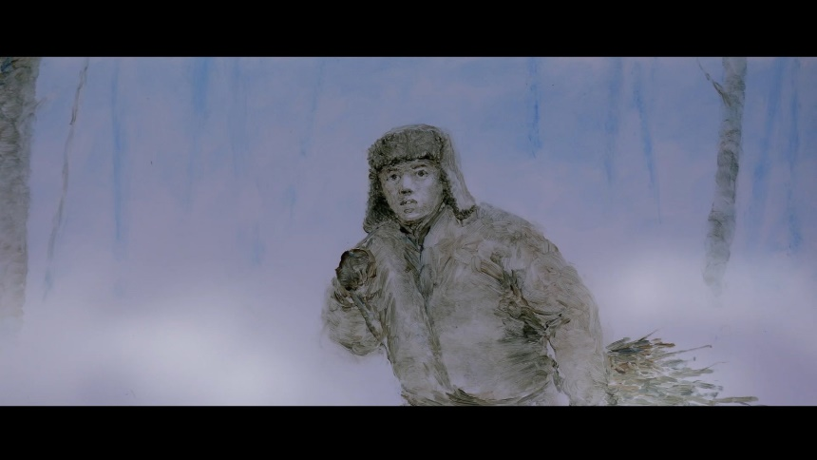
The Winter – Animation - 5 min. by Xin Li, Melbourne, Australia
Timestamp – 29:14 [Footsteps in the snow]
29:27 [chimes]
30:35 [music intensifies]
31:30 [silence]
31:33 [soft music]

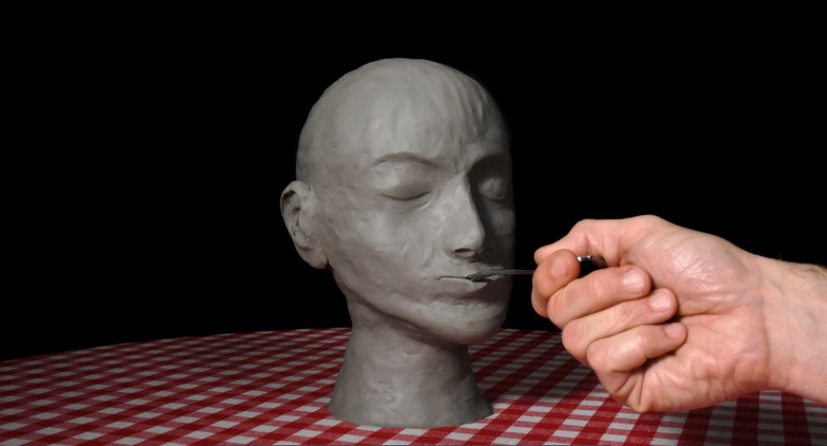
Lairs – Experimental - 2 min. by Emma Penaz Eisner, San Francisco, CA, US
Timestamp – 33:47 [rhythmic thumping]
33:57 [Man’s Voice and Audelade begins]
Audelade: at home, the fireplace stuttering until May.
The couple next door were like us, reassured in the cold while fire light gilded the dim and hollowed reaches their winter house.
In the season yielded abruptly, bright evenings parse them and relief.
Man, woman, long, the heat growing hateful. Refusing to leave.
Its sculpt in the garden and suck the lavenders dry. Until only an occasional wind affects them to sudden vitality.
Flower pulps, leaves like razors, core stems the tangled in perfidies, neither he nor she can find them.
Men, women, lawn, and dinner Alfresco on the patio. Their tongues, ladling filmy spoons, later puddled in the kitchen sink.
Around the joint where spoon bowl meets its handled, lips puckering like garden soil clenching a stem and circling their pale waning bodies.
A threaded cyclone of heat, drilling the lurid sky.
35:05 [birds sing]

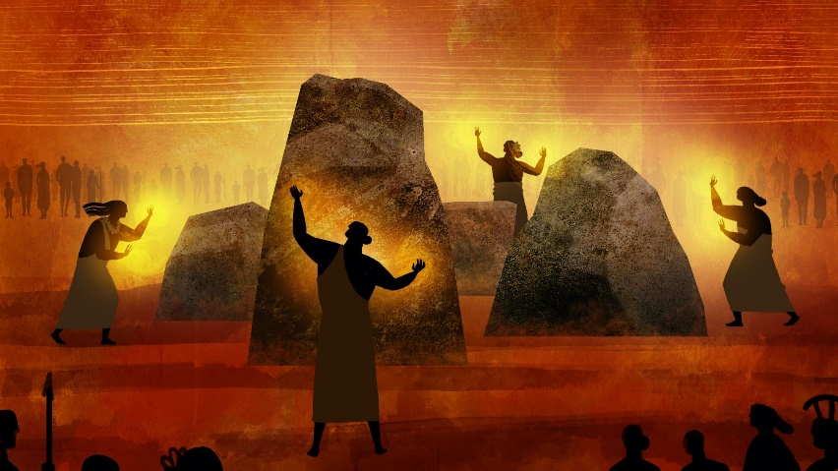

Kapaemahu - Animation - 8 min. by Hinaleimoana Wong-Kalu, Dean Hamer, and Joe Wilson, Honolulu, HI, US

Timestamp – 35;34 [hum of a fire]
35:35 [thump]
35:45 [thump]
35:49 [Native tongue]
35:36 [soft music]
36:25 [conch shell tone]
36:26 [native tongue]
36:36 [water breaking on shore, footsteps]
36:46 [native tongue]
37:25 [Pahu drum tapping]
38:41 [wind and sea]
39:18 [bell tolls]
39:55 [chanting song]
40:43 [whoosh]
42;10 [long tone]
42:17 [long tone]
42:44 [enlightened call]
42:50 [Chanting and Pahu drum]

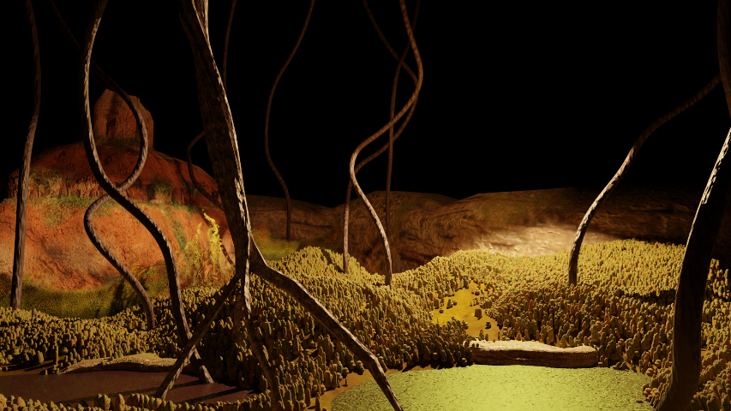

Beneath - Animation - 5 min. by Ian Martinez, Nevada City, CA, US

Timestamp – 44:03 [soft music]
46:13 [music intensifies]
46:47 [music stops]
46:54 [long tones]
48:10 [wind blows]

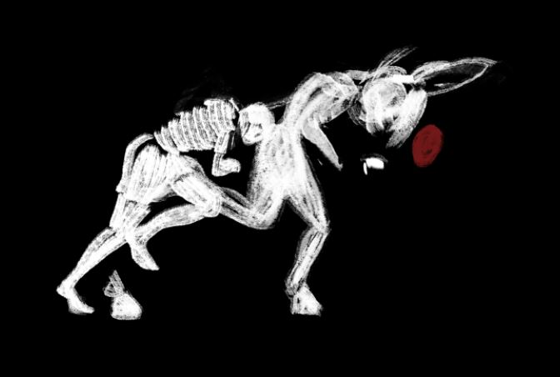
We, the Slow – Animation - 5 min. by Jeanne Waltz, Lisbon, Portugal
Timestamp – 48:48 [machine starts]
49:10 [unintelligible voices]
49:21 [Cheering whistles and gunshot]
49:29 [mechanical music]
49:40 [fireplace burning]
49:48 [baby coos and giggles]
50:00 [squeaking playground equipment]
50:08 [birds singing]
50:10 [thump]
50:17 [mule bellows]
50:23 [water running]
50:44 [squeaking]
50:52 [wind blowing]
50 :59 [unintelligible speech]
51:10 [runner panting]
51:20 [tide slapping the shore]
51:37 [gulls calling]
52:00 [tree crashes]
52:02 [wind]
52:10 [soft music]
52:20 [rustling]
52:40 [clock ticking]
52:50 [baby babbling]

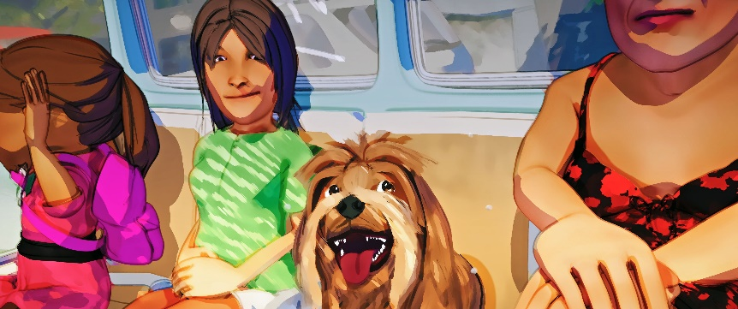

Metro6 - 8 min. by Geoff Hecht, San Francisco, CA
Timestamp – 53:43 [upbeat music]
53:48 [cleansing breath, beep beep]
53:52 [camera clicks]
53:56 [bubbles popping, cleansing breath]
53:58 [BAM]
54:02 [boop, boop, ssssssssssssssss]
54:04 [car horn, sigh]
54;06 [squealing tires]
54:11 [AH!]
54:14 [car horn]
54:29 [rattling of paint cans]
54:51 [thumping]
55:04 [ah]
55:19 [AH]
55:23 [UGH]
55:24 [bark]
55:46 [OO, YES]
55:49 [bark]
55:58 [AH HA]
56:00 [thump]
56:05 [video game music]
56:09 [sigh]
56:24 [upbeat music]
56:30 [child laughs]
56:36 [bubbles popping]
56:41 [video game music]
56:44 [HUH}
56:46 [AHHH!]
56:52 [slurp]
56:54 [yum]
57:02 [tires screech]
56:06 [AAH]
57:09 [tires screech]
57:11 [car horns]
57:25 [coffee pouring]
57:32 [screams]
57:38 [whimsical music]
57:58 [AAHHH!!!]
58:08 [YA HA!]
58:12 [bark]
58:13 [whimsical music continues]
58:23 [beep beep]
58:31 [siren]
58:37 [bus shuts down, music stops]
58:42 [thump]
58:54 [keyboard clicks]
58:57 [bus starts, horn beeping]
59:08 [traffic horns]
59:11 [clears throat]
59:15 [trumpeted TA DA]
59:20 [paper crinkles]
59:25 [elevator dings]
59:28 [footsteps sad music]
59:31 [car horn]
59:36 [grrrr]
59:43 [bubbles popping]
59:46 [car horn]
59:48 [bubbles popping]
59:58 [bus approaching]
1:00:00 [upbeat music]
1:00:47 [crescendo]

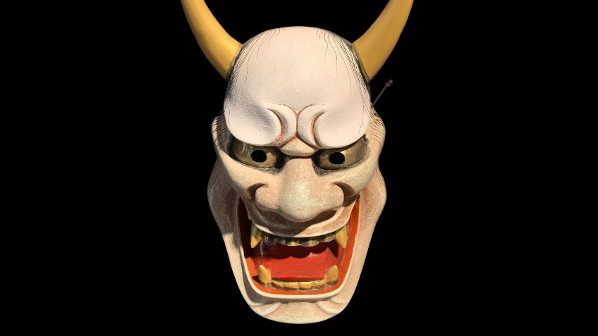
Beyond Noh - 3 min. by Patrick Smith, NY, NY and Kaori Ishida, Osaka, Japan
Timestamp – 1:02:08 [Taiko fluttering]
1:02:21 [Taiko TAP, TAP…]
1:02:26 [Taiko fluttering]
1:02:28 [Taiko TAP, TAP…]
1:02:36 [Taiko fluttering]
1:02:44 [Rhythmic playing of the Taiko]
1:03:18 [Taiko stops]
1:03:20 [Taiko fluttering]
1:03:32 [Rhythmic playing of the Taiko]
1:04:13 [silence]
1:04:15 [Taiko fluttering]
1:04:26 [Rhythmic playing of the Taiko]
1:05:18 [silence]

1:05:56 Film series ends [camera shutting down]

